**SOURCES OF WATER**

**Ground water development**

With regard to of water below the earth crust at different level, it is divided into following.

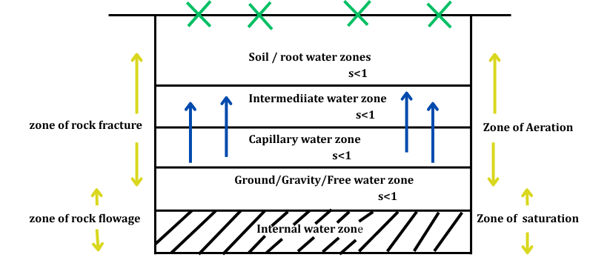

1. **Zone of Rock Flowage**
   * It is the zone in which medium particles are being subjected to permanent deformation due to the application of plastic stress over them.
   * Water is this zone is present inside the structure of the medium particles (hence is turned internal water).
   * Thickness of this zone extends up to several kilometers below the earth crust.
   * This zone is of no engineering use, as water cannot be derived from it by any means.
2. **Zone of Rock fracture**
   * It is the zone in which medium particles are subjected to elastic stress, hence water is present in the voids of this zone extraction of which depends on properties of medium (ɳ, k).
   * Thickness of zone extends up to 100-1000 m below the earth crust.
   * This zone is further classified into.
     + Zone of saturation.
     + Zone of Aeration.

* Zone of saturation is the zone in which voids are filled ground water saturation.
* Water is this is subjected no pressure other than hydrostatic pressure.